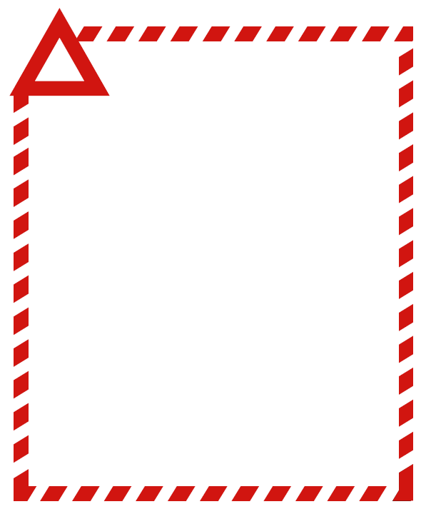

**FOOD RECALL NOTICE**

**<Company Name>**

**<Brand Product Name 1> <Pack Details 1>**

<Batch Information 1> <Date Information 1>

**<Brand Product Name 2> <Pack Details 2>**

<Batch Information 1> <Date Information 1>

**<Product Image(s)>**

Attention customers

<Company Name> is recalling the above product(s) due to <Reason for Recall>.

If you have purchased this/these product(s), do not consume. There have been no reports of illness/injury, however if you have consumed this/these product(s) and have any concerns about your health, seek medical advice.

Please return the product(s) to this store for a full refund (or other consumer advice on recalled products).

<Company Name> Ltd wishes to apologise to our customers for any inconvenience that this may cause.

<Name>

<Position> (Optional)

<Company Contact Details> (Optional)

Version <#> <dd/mm/yyyy>