Review of Sustainability Measures for Rock Lobster (CRA 3, 4 & 8) for 2019/20
Proposal to Alter Total Allowable Catches, Allowances, and Total Allowable Commercial Catches

Discussion Document No: 2018/09

Prepared for consultation by Fisheries New Zealand

ISBN No: 978-1-98-857187-4 (online)
ISSN No: 2624-0165 (online)

December 2018

Disclaimer

While every effort has been made to ensure the information in this publication is accurate, Fisheries New Zealand does not accept any responsibility or liability for error of fact, omission, interpretation or opinion that may be present, nor for the consequences of any decisions based on this information.

Requests for further copies should be directed to:

Publications Logistics Officer
Ministry for Primary Industries
PO Box 2526
WELLINGTON 6140

Email: brand@mpi.govt.nz
Telephone: 0800 00 83 33
Facsimile: 04-894 0300

This publication is also available on the Ministry for Primary Industries website at
http://www.mpi.govt.nz/news-and-resources/publications/

Front page photo credit: Malcolm Francis

© Crown Copyright – Fisheries New Zealand

Contents Page

1 Submission information 1
2 What is proposed? 2
3 Why the need for change? 3
4 Background information 5
4.1 Management approach for rock lobster stocks 5
4.2 Definition of stock indicators 5
4.3 Harvest Strategy Standard 6
5 Review of the CRA 3 (Gisborne) Rock Lobster Fishery 6
5.1 Fishery overview 6
5.2 CRA 3 stock status 8
5.3 The current CRA 3 management procedure 9
5.4 Proposed CRA 3 options 10
6 Review of the CRA 4 (Hawke’s Bay/Wellington) Rock Lobster Fishery 12
6.1 Fishery overview 12
6.2 CRA 4 stock status and previous actions 15
6.3 The current CRA 4 management procedure 16
6.4 Proposed CRA 4 options 16
7 Review of the CRA 8 (Southern) Rock Lobster Fishery 18
7.1 Fishery overview 18
7.2 CRA 8 stock status 20
7.3 The current CRA 8 management procedure 21
7.4 Proposed CRA 8 options 22
8 Other relevant matters 24
8.1 Deemed Value rates 24
9 Further information 25

Appendix 1: Statutory considerations 26
Section 5(a) – International Obligations 26
Section 5(b) – Treaty of Waitangi (Fisheries Claims) Settlement Act 1992 26
Section 8 – Purpose of the Fisheries Act 1996 26
Section 9 – Environmental principles 27
Section 10 – Information Principles 28
Section 11 – Sustainability Measures 29
Section 12 – Consultation and Input and Participation of Tangata Whenua 29
Section 13 - Setting and Variation of The Total Allowable Catch 31
Sections 20 & 21 - Setting and Variation of the Total Allowable Commercial Catch 33

Submission Information
- Fisheries New Zealand and the multi-sector National Rock Lobster Management Group (an advisor on rock lobster management matters) welcomes written submissions on any or all of the measures by proposed in this Discussion Paper. All written submissions must be received by Fisheries New Zealand no later than 5pm on Tuesday 12 February 2019.

- Written submissions should be emailed to FMsubmissions@mpi.govt.nz

or sent directly to:

Sustainability Review 2019
Fisheries Management
Fisheries New Zealand
P O Box 2526
Wellington 6140.

- All submissions are subject to the Official Information Act and can be released (along with personal details of the submitter) under the Act. If you have specific reasons for wanting to have your submission or personal details withheld, please set out your reasons in the submission. Fisheries New Zealand will consider those reasons when making any assessment for the release of submissions if requested under the Official Information Act.

Rock lobster (CRA 3, 4 and 8)
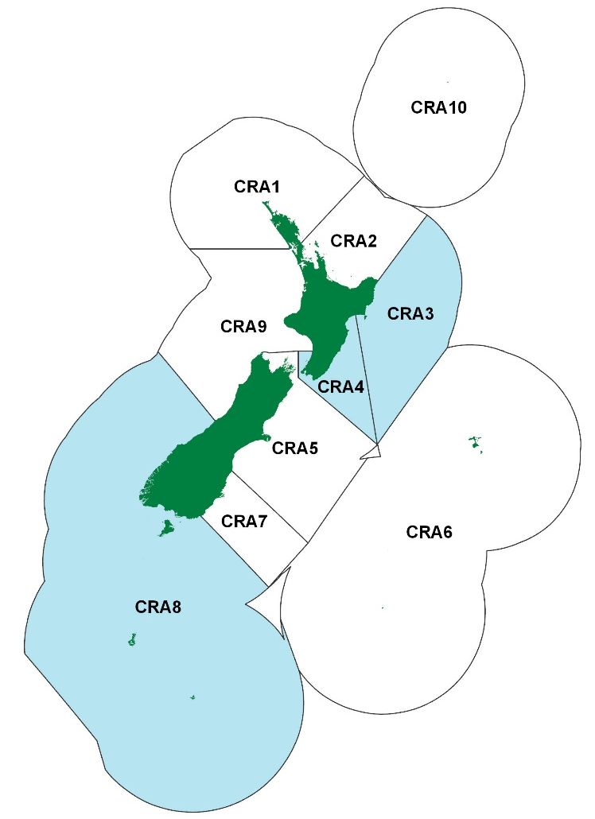
Figure 1: Map of rock lobster Quota Management Areas, showing stocks under review in blue.

What is proposed?
- It is proposed that the Total Allowable Catch (TAC), allowances and the Total Allowable Commercial Catch (TACC) are reviewed for rock lobster (Jasus edwardsii) in Quota Management Areas CRA 3, 4 and 8 (Figure 1). Fisheries New Zealand and the National Rock Lobster Management Group (an advisor on rock lobster matters) welcomes tangata whenua and stakeholder feedback to inform a review of rock lobster sustainability measures for 1 April 2019.

- The TAC, allowance and TACC proposals presented in this paper are based on the results from the operation of management procedures (or ‘decision rules’). Fisheries New Zealand and the National Rock Lobster Management Group considered this information, and the Minister of Fisheries (the Minister’s) statutory obligations, in developing the options for consultation.

- Management procedures are in place for most rock lobster stocks in New Zealand. Each management procedure is operated every year to guide the setting of catch limits in a way that is consistent with the Minister’s statutory obligations for managing stocks within the Quota Management System. Management procedures are designed to move or maintain stock abundance at or above agreed reference levels, while recognising a range of customary Māori, recreational, and commercial values.

- Table 1 provides a summary of the options proposed for rock lobster for the fishing year beginning on 1 April 2019 fishing. These include:
- A TAC and TACC decrease for the CRA 3 (Gisborne) fishery to ensure stock abundance is maintained above agreed reference levels, with no changes to the other allowances at this time (this will be considered as part of the proposed stock assessment in 2019);
- TAC and TACC increases for the CRA 4 (Hawke’s Bay/Wellington) and CRA 8 (Southern) fisheries to provide increased utilisation opportunities; and
- A decrease to the other mortality allowance for CRA 4 to reflect more accurately the estimates used in the most recent CRA 4 stock assessment.

Table 1: Proposed management options (in tonnes) for CRA 3, 4 and 8 from 1 April 2019.
Stock | Option |  |  | Allowances
 |  | TAC | TACC | Customary Māori | Recreational | Other mortality
CRA 3 | CRA3_01: Status quo | 366.86 | 237.86 | 20 | 20 | 89
 | CRA3_02: Based on the operation of the CRA 3 management procedure | 351.9 (4.1%) | 222.9 (6.3%)
CRA 4 | CRA4_01: Status quo | 513.8 | 318.8 | 35 | 85 | 75
 | CRA4_02: Based on the operation of the CRA 4 management procedure | 558 (8.6%) | 380 (19.2%) |  |  | 58 (22.7%)
CRA 8 | CRA8_01: Status quo | 1,161.7 | 1,070.7 | 30 | 33 | 28
 | CRA8_02: Based on the operation of the CRA 8 management procedure | 1,220.6 (5.1%) | 1,129.6 (5.5%)

Why the need for change?
- Every year Fisheries New Zealand and the National Rock Lobster Management Group consider the results from stock assessments or the operation of management procedures. This process informs advice to the Minister and decisions on whether catch settings should change for the upcoming April fishing year, to provide for utilisation while ensuring sustainability.

- Full scientific assessments of most rock lobster stocks are carried out every four to five years. These assessments estimate the current status of the stock relative to the desired levels of abundance, and also show how the stock has responded to previous management controls. In between years, management procedures are used in most rock lobster stocks (except for CRA 2 – Hauraki Gulf/Bay of Plenty, CRA 6 – Chatham Islands, and CRA 9 – Westland/Taranaki) to guide the annual setting of TACs.

- Management procedures set out pre-agreed management actions that will be taken in response to annual changes in commercial catch rates (‘catch-per-unit-effort’ or ‘CPUE’). Commercial CPUE is considered to be a reliable indicator of relative stock abundance.

- Each stock’s management procedure is generally reviewed every five years unless an earlier review is requested and approved by Fisheries New Zealand, and the National Rock Lobster Management Group. The review is to ensure that TAC setting remains compliant with the statutory structure set out in the Fisheries Act 1996 (the Act). It involves a new stock assessment and management procedure evaluations to determine whether there are opportunities for increased utilisation, or sustainability risks that require a management response.

- Table 2 provides an outline of the use of current management procedures, and when they are scheduled for review.

Table 2: Management procedures: history and review schedule.
 | CRA 1 | CRA 3 | CRA 4 | CRA 5 | CRA 7 | CRA 8
Year current management procedure commenced | 2015 | 2015 | 2017 | 2016 | 2013 | 2016
Year of scheduled review | 2019 | 2019 | 2021 | 2020 | 2020 | 2020

- Based on operation of current management procedures, changes to the status quo are proposed for the CRA 3, 4, and 8 rock lobster fisheries. Operation of the CRA 1 (Northland), CRA 7 (Otago), and CRA 5 (Canterbury/Marlborough) management procedures suggested that no change was needed to the management settings for these fisheries from April 2019.

Discussion question:
- Do you agree with the need for change?

- There is no new information to suggest that changes to the catch settings are needed for the CRA 2 (Hauraki Gulf/Bay of Plenty), and CRA 9 (Taranaki/Westland) fisheries. A new stock assessment was completed for CRA 6 (Chatham Islands) in 2018, which suggested that there were no sustainability concerns for the stock, and that no changes were required to current catch settings.

- A rebuilding strategy is currently in place for the CRA 2 fishery, following substantial reductions that were made to the TACC (down from 200 to 80 tonnes), and the recreational allowance (down from 140 to 34 tonnes) from April 2018. Consultation on proposals to reduce the CRA 2 recreational bag limit from six to three spiny rock lobsters, and to introduce telson clipping for recreationally caught spiny lobsters, ends/ended on 19 December 2018. A review of the CRA 2 TAC, allowances, TACC, and other management controls is proposed at the time of the next CRA 2 stock assessment (currently proposed for 2021).

Background Information
- This section provides relevant background information on the management approach for rock lobster, stock indicators, and the Ministry for Primary Industries (MPI) Harvest Strategy Standard.

Management Approach for Rock Lobster Stocks
- The overall management approach for rock lobster fisheries is to monitor and manage them closely to provide for utilisation while ensuring sustainability. The use of responsive management procedures and regular review of rock lobster TACs is consistent with this management approach. Being able to respond to changes in rock lobster abundance is important because rock lobster populations can fluctuate fairly rapidly in response to changes within their environment.

- Since 1992, the National Rock Lobster Management Group has acted as an advisor to Minister’s on catch limit, regulatory and other management actions that apply specifically to rock lobster fisheries. The National Rock Lobster Management Group is a national-level, multi-stakeholder group comprising representatives of customary, recreational and commercial fishing sectors and Fisheries New Zealand. It is the longest standing collaborative fisheries multi-stakeholder group in New Zealand.

- The National Rock Lobster Management Group’s management goal is for all rock lobster fisheries: “to be managed and maintained at or above the assessed and agreed reference levels, using a comprehensive approach that recognises a range of customary Māori, amateur, commercial and environmental concerns and values”.

Definition of Stock Indicators
- Two stock indicators are relevant to evaluation of the proposals presented in this paper:
- The conceptual proxy, B_{REF}, a reference biomass level. The use of B_{REF} is a way of assessing a stock that is not inconsistent with the objective of maintaining a stock at or above, or moving the stock towards, a level that can maintain the maximum sustainable yield (MSY). This “not inconsistent” approach is set out in section 13(2A) of the Act where the Minister considers that current biomass or B_{MSY} cannot be estimated reliably using best available information. B_{REF} is generally a stock size at or above the stock size associated with a period in the fishery that showed good productivity and was demonstrably safe.
- Spawning stock biomass, SSB, which is the weight of all mature females in the autumn-winter.

Harvest Strategy Standard
- The Harvest Strategy Standard is a policy statement of best practice in relation to the setting of fishery and stock targets and limits for fishstocks in the Quota Management System. It outlines Fisheries New Zealand’s approach to relevant sections of the Act, and as such, forms a core input to advice to the Minister on the management of fisheries, particularly the setting of TACs under section 13. The Harvest Strategy Standard is not, however, legally binding and the Minister is not obliged to choose options based on it.

- The Harvest Strategy Standard specifies that management procedures should be designed to ensure that the probability of:
- Achieving the MSY-compatible target or better is at least 50%;
- Breaching the soft limit does not exceed 10%; and
- Breaching the hard limit does not exceed 2%.

- For rock lobster:
- The soft limit is defined as 20% of the unfished spawning stock biomass level; and
- The hard limit is defined as 10% of the unfished spawning stock biomass level.

Review of the CRA 3 (Gisborne) Rock Lobster Fishery

Fishery Overview
Māori customary fishing
- Rock lobster (koura) is a taonga species for tangata whenua. Information on CRA 3 customary catches is available under the Fisheries (Kaimoana) Regulations 1998, and regulation 50 of the Fisheries (Amateur Fishing) Regulations 2013. In the 2017 calendar year, approximately 8,400 rock lobsters were reported as customary harvest from CRA 3. This information is considered incomplete, because customary take of rock lobster that occurs under the Amateur Regulations for the purposes of hui and tangi is not required to be reported.

- An estimate of 20 tonnes was used in the last 2014 CRA 3 stock assessment model to represent customary catches.
Recreational fishing
- The CRA 3 rock lobster fishery supports a popular recreational fishery along the East Coast of the North Island, including in areas such as Poverty Bay and Mahia.

- Recreational fishers are not required to report the quantities of rock lobsters they catch. For the 2014 CRA 3 stock assessment, recreational catch estimates from 1992, 1996 and 2011 recreational harvest surveys were used to construct a recreational catch trajectory (Figure 2). The trajectory was developed by assuming that recreational catch was proportional to the CRA 3 spring-summer abundance, as reflected by spring-summer commercial CPUE for CRA 3.

- The resulting recreational catch trajectory showed a strong increasing trend from the early 1990s, exceeding 20 tonnes in the late 1990s, and then a strong decreasing trend in the early 2000s before an increase was seen in the late 2000s. In 2013, the model estimate of recreational catch was 20.42 tonnes.

- The 2011 recreational catch estimate comes from the 2011/12 National Panel Survey, which estimated that the recreational catch of rock lobsters was 8.07 tonnes. There is considerable uncertainty in this estimate.

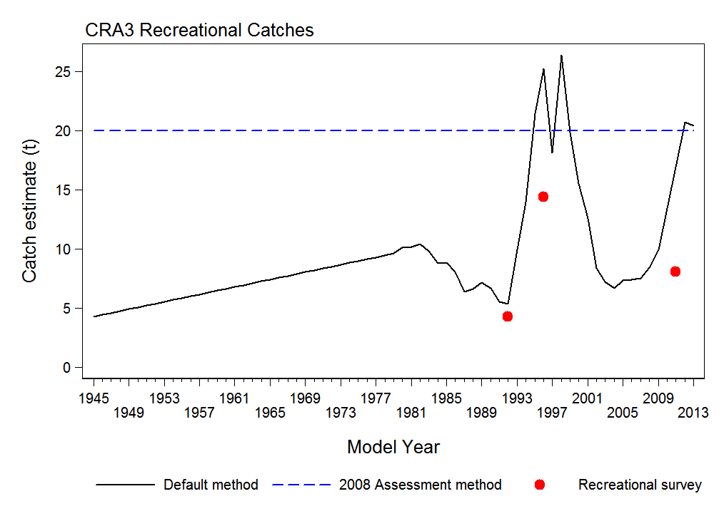
Figure 2: Recreational catch trajectory (tonnes) for the 2014 stock assessment of CRA 3. The red dots are the recreational survey estimates from 1992, 1996 and 2011, the solid black line is the recreational catch trajectory, including section 111 catches, and the blue dashed line is the recreational catch estimate used in the 2008 stock assessment (a constant 20 tonnes).

Other mortality
- There are various potential other sources of mortality caused by fishing, such as illegal catch and handling mortality. It is difficult to get an accurate estimate of illegal catch given that illegal activity is not easily detected. However, the Rock Lobster Fisheries Assessment Working Group used available estimates from 1989 and a constant illegal catch of 89 tonnes per year from 2002 to 2013.
Commercial fishing
- Fisheries New Zealand estimates the current asset value of the CRA 3 fishery to be over $222 million based on the current TACC and the 2017/18 average quota share price. The average Annual Catch Entitlement (ACE) value (the earnings quota owners receive when setting their ACE) for the 2017/18 fishing year was $50,515 per tonne for CRA 3.

- Annual landings and the TACC for CRA 3 since 1990 are shown in Figure 3. Prior to 1995, there was a New Zealand wide stock assessment with catches apportioned to each Quota Management Area, and TACCs were not set on an annual basis to reflect available abundance. Since 2010, a management procedure has been used in CRA 3 to annually review the TACC to ensure that catches reflect available abundance.
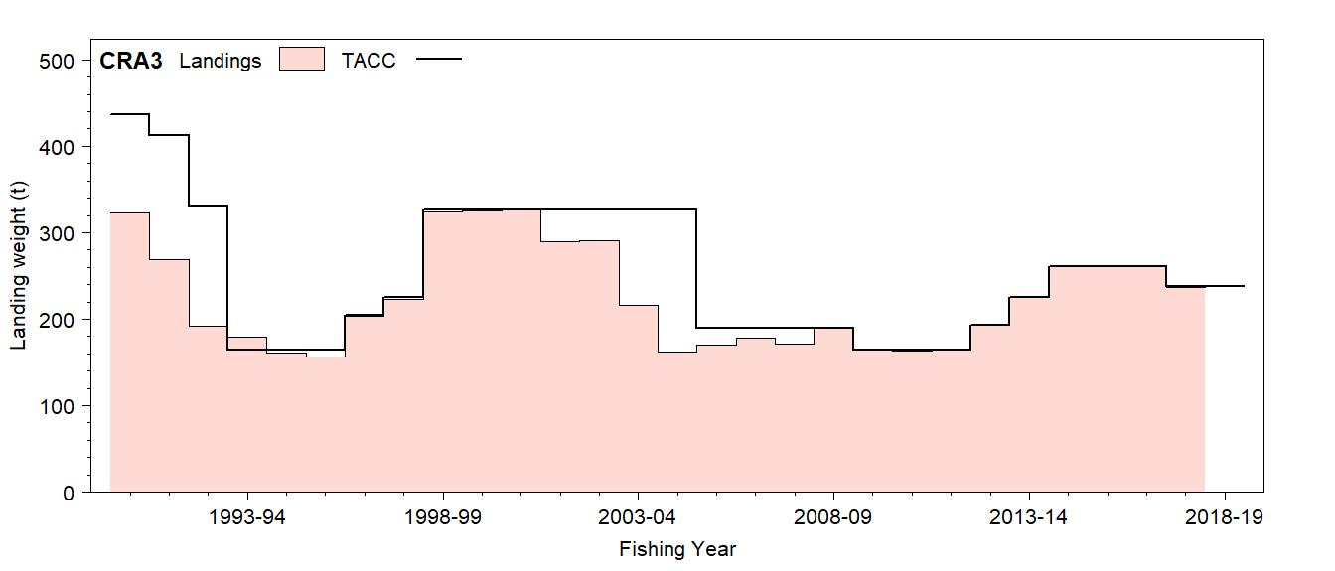
Figure 3: CRA 3 commercial landings and the TACCs from 1990 to 2018.

CRA 3 Stock Status
- The results of the most recent CRA 3 stock assessment conducted in 2014 suggested there were no sustainability concerns for the CRA 3 fishery. 2013 biomass was well above both B_{MSY} (3.3 to 4.7 times) and B_{MIN} (3.0 to 3.6 times). Spawning stock biomass in 2013 was 70-107% of the unfished level.

- With 2013 catch levels and recent recruitments, biomass was projected to decline by 15-31% by 2017, but would remain well above reference points.

- Standardised CPUE is considered to be a reliable indicator of relative stock size in CRA 3 and is the abundance indicator used in the CRA 3 management procedure. The history of offset year (i.e. October through September) CRA 3 commercial CPUE is shown in Figure 4. CPUE increased from 2008 to 2012, then declined but remains relatively high. CPUE in 2018 is lower than that in 2014 by about 30%, however stock biomass is still very likely to be above B_{MSY}.
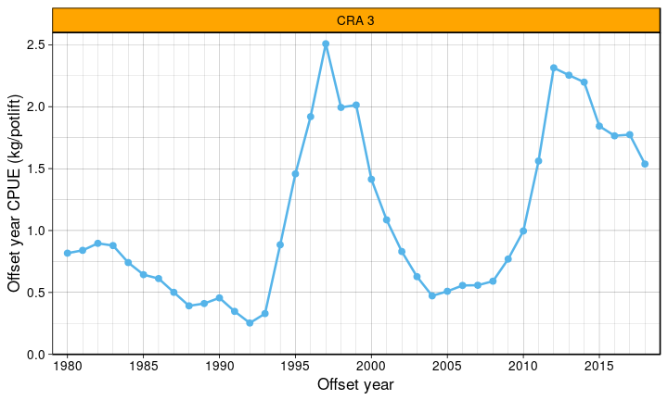
Figure 4: CRA 3 CPUE from 1980 to 2018 (kg/potlift).

the current cRA 3 management procedure
- The Government agreed to use the current CRA 3 management procedure in 2015 to form the basis for management action to the 2020/21 fishing year. A graphical representation of the CRA 3 management procedure is provided in Figure 5. The graph shows the proposed TACC for the next year as a function of CPUE in the current year.

- The 2018 standardised CPUE was 1.54 kg/potlift, a decrease from 1.79 kg/potlift in 2017. When the rule was operated with the 2018 CPUE, it resulted in a TACC of 222.9 tonnes (shown by the pink square on the graph).

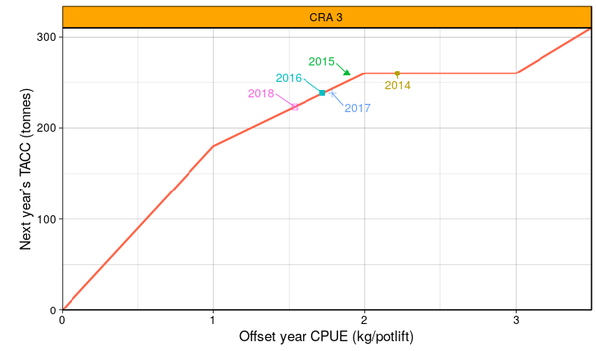
Figure 5: The CRA 3 management procedure, showing the TACCs resulting from the rule evaluations performed in 2014 through 2018 for the 2014/15 through 2019/20 fishing years (shown as coloured shapes).

Proposed CRA 3 Options
- Table 3 provides a summary of the options proposed for CRA 3. The current CRA 3 management procedure has been used to guide TAC setting options. The proposals to decrease the TAC and TACC are expected to ensure the CRA 3 stock is maintained above B_{MSY}.

Table 3: Proposed TAC, allowance and TACC options (in tonnes) for CRA 3 from 1 April 2019.
Option |  |  | Allowances
 | TAC | TACC | Customary Māori | Recreational | Other mortality
CRA3_01: Status quo | 366.86 | 237.86 | 20 | 20 | 89
CRA3_02: Based on the operation of the CRA 3 management procedure | 351.9 (4.1%) | 222.9 (6.3%)

Total Allowable Catch

- For CRA 3, the biomass level that can produce the maximum sustainable yield (B_{MSY}) is known. Accordingly, two options are presented below for the CRA 3 TAC to maintain the stock at or above B_{MSY} (section 13(2)(a)). For further information on the Minister’s statutory considerations refer to Appendix 1.

- Under Option CRA3_02, the CRA 3 TAC would stay at its current level of 366.86 tonnes from 1 April 2019. This option is not supported by Fisheries New Zealand, nor by the National Rock Lobster Management Group. Maintaining the current TAC could result in a further decline in CRA 3 stock abundance and could affect the goal of maintaining stock biomass at or above B_{MSY}.

- Under Option CRA3_02, the CRA 3 TAC would be decreased to 366.86 tonnes (a 4.1% decrease). The proposed TAC decrease is guided by the use of the CRA 3 management procedure. The National Rock Lobster Management Group supports the use of management procedures unless there are compelling reasons in a particular case not to follow the procedure.

- Ongoing application of the CRA 3 management procedure is expected to maintain the stock above B_{MSY} with greater than 50% probability. Simulation testing indicates it would maintain the stock above B_{MSY} with 99% probability. This is likely to maintain utilisation benefits for all sectors.

Allowances

- Table 4 provides a summary of information on current non-commercial allowances for CRA 3 and stock assessment assumptions of non-commercial catch.

Table 4: Current CRA 3 allowances and model assumptions of non-commercial catches (in tonnes).
CRA 3 | Customary  Māori | Recreational | Other mortality | Total
Current allowances | 20 | 20 | 89 | 129
Non-commercial catch assumptions  for the 2014 stock assessment | 20 | Assumed to vary with biomass. Estimated at 20.42 for 2013. | 89 | 129.42

Customary Māori fishing
- No change is proposed to the 20 tonne customary Māori allowance for CRA 3. While noting the incompleteness and uncertainty in the CRA 3 customary harvest information, it is assumed that current harvest is within the 20 tonne allowance allocated for customary Māori interests.

Recreational fishing
- No change is proposed to the 20 tonne recreational allowance for CRA 3. There is uncertainty in this current estimate of recreational catch.

- The 20 tonne recreational allowance was first set in 2005 on the basis of estimates available from surveys at the time, which are now considered to be biased and likely to be overestimates. New information on CRA 3 recreational harvest is expected in 2019 from the 2017/18 National Panel Survey of recreational harvest. This information will be considered as part of the new CRA 3 stock assessment currently proposed for 2019, which will help to inform whether the CRA 3 recreational allowance should be varied or other management controls should be considered. If CRA 3 stock abundance continues to decline, a review of management controls for all sectors is likely to be considered.

Other mortality
- No change is proposed to the 89 tonne CRA 3 allowance for other sources of fishing-related mortality. It is considered that there are moderate to high levels of illegal fishing in CRA 3, however it difficult to get an accurate estimate given that illegal take is not easily detected.

- The 89 tonne other mortality allowance was first set in 2005 based on historical (and uncertain) illegal take estimates. Fisheries New Zealand, along with Fisheries Compliance are currently exploring ways to estimate illegal take better. A new estimate of illegal take should be available in time to inform a new CRA 3 stock assessment currently scheduled for later in 2019. An estimate of handling-related mortality should also be available from the proposed 2019 CRA 3 stock assessment. The intention is for this information to be considered in future TAC setting, and in the setting of allowance for other sources of fishing-related mortality.

Total Allowable Commercial Catch

- Under Option CRA3_01, the CRA 3 TACC would stay at its current level of 237.86 tonnes. This option would maintain the current commercial utilisation opportunities.

- Under Option CRA3_02, the CRA 3 TACC would be decreased to 222.9 tonnes from 1 April 2019, as guided by the use of the CRA 3 management procedure. The proposed 15 tonne TACC decrease has the potential to result in a loss of annual revenue to the catching sector alone of approximately $1.2 million (based on 2017 average port price information).
Discussion questions:
- Do you agree that these are the correct options to consider? If not, why not?

Review of the CRA 4 (Hawke’s Bay/Wellington) Rock
Lobster Fishery

Fishery Overview
Māori customary fishing
- Rock lobster (koura) is a taonga species for tangata whenua. Information on Māori customary catch of rock lobster indicates that tangata whenua use of customary Māori harvesting rights for taking rock lobster is minimal and was well within the current customary Māori allowance for CRA 4 of 35 tonnes. In the 2017 calendar year, approximately 430 rock lobsters were reported as harvested from CRA 4. This information is considered incomplete, because customary take of rock lobster that occurs under the Amateur Regulations for the purposes of hui and tangi is not required to be reported.

- An estimate of 20 tonnes was used in the 2016 CRA 4 stock assessment model to represent customary catches.
Recreational fishing
- The CRA 4 rock lobster fishery supports a valuable recreational fishery in Hawke’s Bay, the Wairarapa Coast, through Cook Strait to the lower West Coast of the North Island.

- Recreational fishers are not required to report the quantities of rock lobsters they catch. For the 2016 CRA 4 stock assessment, recreational catch estimates from 1994, 1996 and 2011 recreational surveys were used to construct a recreational catch trajectory (Figure 6). The trajectory was developed by assuming that recreational catch was proportional to the CRA 4 spring-summer abundance, as reflected by spring-summer commercial CPUE for CRA 4.

- The resulting recreational catch trajectory showed a strong increasing trend up to the end of 1990s, followed by a steep drop to 2007, which recovered by 2013 before dropping again from 2014.

- The 2011 recreational catch estimate comes from the 2011/12 National Panel survey, which estimated that the recreational catch of rock lobsters in CRA 4 was 44.17 tonnes.
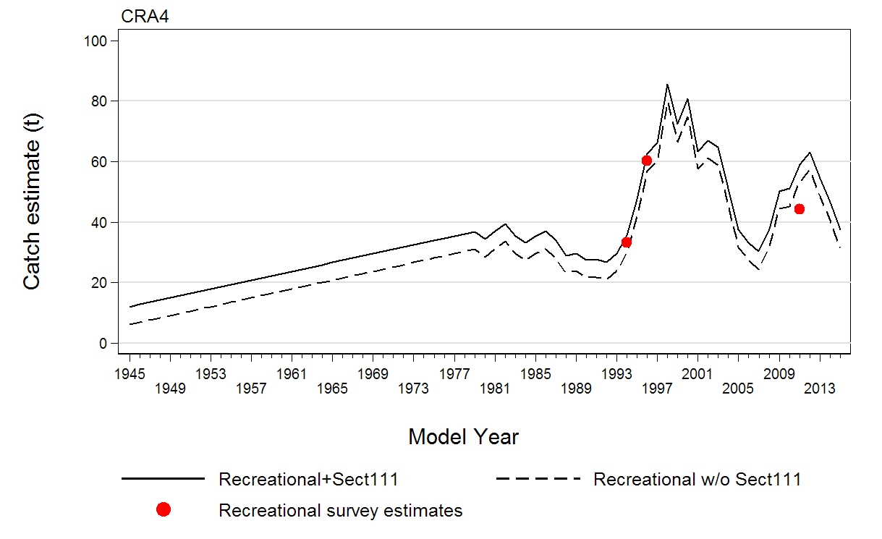
Figure 6: The predicted recreational catch trajectories (tonnes) for the 2016 CRA 4 stock assessment. The red dots are the recreational survey estimates from 1994, 1996 and 2011, the solid black line is the recreational catch trajectory including section 111 catches, and the dashed black line is the recreational catch trajectory without section 111 catches.

Other mortality
- There are various potential other sources of mortality caused by fishing, such as illegal catch and handling mortality. It is difficult for Fisheries New Zealand to get an accurate estimate of illegal catch given that illegal activity is not easily detected. However, the Rock Lobster Fisheries Assessment Working Group used available Ministry for Primary Industries estimates from 1990 to 2004 in the 2016 stock assessment model to estimate illegal catches. For the 2015/16 fishing year, while uncertain, the illegal catch estimate assumed for the model was 40 tonnes.

- The 2016 CRA 4 assessment also assumed that handling mortality was 10% of returned lobsters until 1990 and then 5% thereafter. The 2016 model estimate of handling mortality was 18.14 tonnes.
Commercial fishing
- Fisheries New Zealand estimates the current asset value of the CRA 4 fishery to be over $357 million based on the current TACC and the 2017/18 average quota share price. The average Annual Catch Entitlement (ACE) value (the earnings quota owners receive when setting their ACE) for the 2017/18 fishing year was $46,975 per tonne for CRA 4.

- Annual landings and the TACCs for CRA 4 since 1990 are shown in Figure 7. Prior to 1995, there was a New Zealand wide stock assessment with catches apportioned to each Quota Management Area, and TACCs were not set on an annual basis to reflect available abundance. In 2007 and 2008, the industry used a voluntary management procedure to guide Annual Catch Entitlement shelving. This resulted in the catch limit going down to 340 tonnes in 2007 and 250 tonnes in 2008, and is why the TACC wasn’t fully caught in these years. Since 2012, a management procedure has been used in CRA 4 to review the TACC annually to ensure catches reflect available abundance.
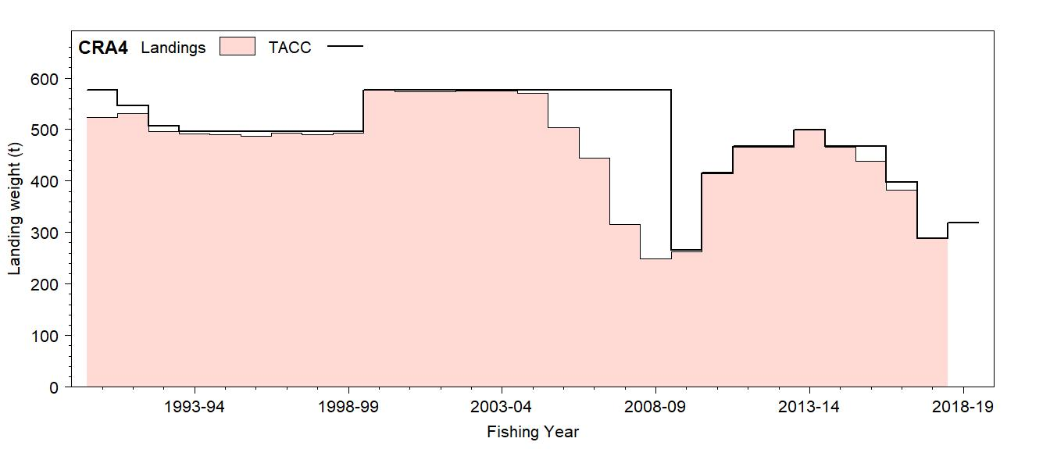
Figure 7: CRA 4 commercial landings and TACCs from 1990 to 2018.

CRA 4 Stock Status and previous Actions
- The results of the CRA 4 stock assessment carried out in 2016 suggested that stock biomass was below the agreed reference level, B_{REF,} by 25%. Spawning stock biomass in 2016 was 51% of the unfished level, well above the soft limit of 20% where it is Fisheries New Zealand policy to implement a formal, time-constrained rebuilding plan.

- Following the 2016 stock assessment results, a new CRA 4 management procedure was agreed for use in guiding TAC setting from April 2017. This was to ensure stock biomass was rebuilt towards the agreed reference level in the next five years. The operation of the management procedure in its first year resulted in a substantial TAC reductions from 592 to 484 tonnes from 1 April 2017.

- Standardised CPUE is considered to be a reliable indicator of relative stock size in CRA 4.It is the abundance indicator used in the current CRA 4 management procedure. The history of CRA 4 commercial CPUE is shown in Figure 8. CPUE increased from 2008 to 2012, then declined. CRA 4 CPUE has increased since 2016 from 0.69 to 0.90 kg/potlift, suggesting rock lobster abundance in CRA 4 has increased.
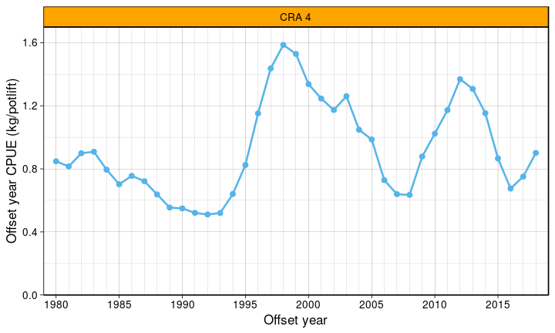
Figure 8: CRA 4 CPUE from 1980 to 2018 (kg/potlift).

the current cra 4 management procedure
- The Government agreed to use the current CRA 4 management procedure in 2017 to form the basis of management action to the 2021/22 fishing year. A graphical representation of the current procedure is provided in Figure 9. The graph shows the proposed TACC for the next year as a function of CPUE in the current year.

- When the rule was operated with the 2018 CPUE of 0.90 kg/potlift, it resulted in an increased TACC of 380 tonnes for the 2019/20 fishing year (shown by the purple square on the graph).
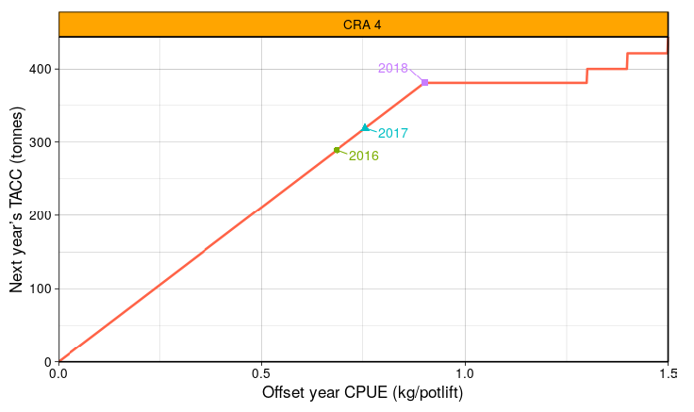
Figure 9: The current CRA 4 management procedure, showing the TACCs resulting from evaluations performed from 2016 to 2018 (shown as coloured shapes) for the 2016/17 to 2019/20 fishing years.

Proposed CRA 4 Options
- Table 5 provides a summary of the options proposed for CRA 4. The current CRA 4 management procedure has been used to guide TAC setting options. The proposals to increase the TAC and TACC will provide for increased utilisation opportunities and are expected to ensure that the stock moves towards its reference level.

Table 5: Proposed TAC, allowance and TACC options (in tonnes) for CRA 4 from 1 April 2019.
Option |  |  | Allowances
 | TAC | TACC | Customary Māori | Recreational | Other mortality
CRA4_01: Status quo | 513.8 | 318.8 | 35 | 85 | 75
CRA4_02: Based on the operation of the CRA 4 management procedure | 558 (8.6%) | 380 (19.2%) |  |  | 58 (22.7%)

Total Allowable Catch

- For CRA 4, the biomass level that can produce the maximum sustainable yield (B_{MSY}) is not known. An MSY-compatible reference level, B_{REF}, is instead used for CRA 4. Because of this, any variation of the CRA 4 TAC must be done having regard to section 13(2A). For further information on the Minister’s statutory considerations refer to Appendix 1.

- Under Option CRA4_01, the CRA 4 TAC would stay at its current level of 513.8 tonnes from 1 April 2019. Compared with Option CRA4_02, this option could result in increased abundance in the CRA 4 fishery in the short-term, increased non-commercial catches and catch rates, and higher CPUE for commercial fishers, which may result in reduced harvesting costs.

- Under Option CRA4_02, the CRA 4 TAC would be increased to 558 tonnes (an 8.6% increase). The proposed TAC increase is guided by the use of the current CRA 4 management procedure. The National Rock Lobster Management Group supports the use of management procedures unless there are compelling reasons in a particular case not to follow the procedure.

- Ongoing application of the CRA 4 management procedure is expected to maintain the stock above the agreed reference level (B_{REF,}) with greater than 50% probability. Simulation testing indicates it would maintain the stock above B_{REF,} with 92% probability. Maintaining the stock above the reference level is likely to provide increased utilisation benefits for all sectors.

Allowances

- Table 6 provides a summary of information on current non-commercial allowances for CRA 4 and stock assessment assumptions of non-commercial catch.

Table 6: Current CRA 4 allowances and model assumptions of non-commercial catches (in tonnes).
CRA 4 | Customary  Māori | Recreational | Other mortality | Total
Current allowances | 35 | 85 | 75 | 195
Non-commercial catch assumptions  for the 2016 stock assessment | 20 | Assumed to vary with biomass. Estimated at 37.5 t for 2015. | 40 t illegal.  18 t handling mortality. | 115.5

Māori customary fishing
- No change is proposed to the 35 tonne customary Māori allowance. While noting the incompleteness and uncertainty in the CRA 4 customary harvest information, it is assumed that current harvest is well within allowance for customary Māori interests at this time.

Recreational fishing
- No change is proposed to the 85 tonne recreational allowance for CRA 4. While there is uncertainty in the current estimate of recreational catch, it is considered to be well within the current 85 tonne allowance.

- The 85 tonne recreational allowance was first set in 1999 on the basis of estimates available from surveys at the time, which are now considered to be biased and likely to be overestimates. A new CRA 4 recreational harvest estimate is expected in 2019 from the 2017/18 National Panel Survey of recreational harvest. This estimate will be considered in future allowance setting, or in a review of other management controls for recreational fishers.

Other mortality
- It is proposed that the 75 tonne CRA 4 allowance for other sources of fishing-related mortality (i.e. illegal catch and handling mortality) be reduced to 58 tonnes, to reflect more accurately the model estimate used in the stock assessment.

Total Allowable Commercial Catch

- Under Option CRA4_01, the CRA 4 TACC would stay at its current level of 318.8 tonnes. This option would maintain the current level of utilisation of the commercial fishery, without realising the potential for increased sustainable utilisation opportunities for commercial fishers.

- Under Option CRA4_02, the CRA 4 TACC would be increased to 380 tonnes from 1 April 2019, as guided by the use of the current CRA 4 management procedure. The proposed 61.2 tonne TACC increase has the potential to result in an increase of annual revenue to the catching sector alone of approximately $4.87 million (based on 2017 average port price information).
Discussion questions:
- Do you agree that these are the correct options to consider? If not, why not?

Review of the CRA 8 (Southern) Rock Lobster Fishery

fishery overview
Māori customary fishing
- Rock lobster (koura) is a taonga species for tangata whenua. Reporting of customary Māori catch of rock lobster is fully operational in the Ngai Tahu rohe moana (including CRA 8). In the 2017 fishing year, approximately 16,500 lobsters, plus 2.3 tonnes were reported as harvested from CRA 8.

- An estimate of 10 tonnes was used in the 2015 CRA 8 stock assessment model to represent customary catches.
Recreational fishing
- The CRA 8 fishery has a number of areas closed to commercial fishing, which provide non-commercial fishers with exclusive access to rock lobsters. In Fiordland, the inner fiords are closed to commercial rock lobster fishing and were established by the Fiordland Marine Guardians under a ‘gifts’ and ‘gains’ approach.

- In the 2015 CRA 8 stock assessment, a recreational catch trajectory was constructed as follows: beginning at 1 tonne in 1945 recreational catch was increased to 5 tonnes in 1979, and then from 1979 to 2014 recreational catch was assumed to be a constant 20 tonnes. In addition, an average of 13 tonnes of rock lobsters were taken over the last three April fishing years by commercial fishers for non-commercial purposes (section 111 take).

- Overall, little is known about recreational catch in CRA 8. Information from the 2011/12 National Panel Survey estimated that 6.9 tonnes of rock lobster were caught by recreational fishers. Given the low number of fishers and events covered in the survey and the high variance, it is assumed that 6.9 tonnes is an underestimate of recreational catch.

- In the absence of any reliable information, in the 2015 CRA 8 stock assessment recreational catch estimates were assumed to be at 1 tonne in 1945 and were increased to 5 tonnes in 1979. A constant estimate of 20 tonnes was assumed from 1979 to 2014.
Other mortality
- There are various potential other sources of mortality caused by fishing, such as illegal catch and handling-related mortality. It is difficult for Fisheries New Zealand to get an accurate estimate of illegal catch given that illegal activity is not easily detected. However, the Rock Lobster Fisheries Assessment Working Group used available estimates from 1990 to 2002 in the 2015 stock assessment model to estimate illegal catches. An estimate of 3 tonnes was used from 2011 to 2014, with the missing years from 2003 to 2010 filled in by scaling the illegal catch down from the 18 tonnes estimated for 2002.
Commercial fishing
- Fisheries New Zealand estimates the current asset value of the CRA 8 fishery to be over $1.37 billion based on the current TACC and the 2017/18 average quota share price. The average Annual Catch Entitlement (ACE) value (the earnings quota owners receive when setting their ACE) for the 2017/18 fishing year was $47,217 per tonne for CRA 8.

- Annual landings and the TACCs for CRA 8 since 1990 are shown in Figure 10. Prior to 1995, there was a New Zealand wide stock assessment with catches apportioned to each Quota Management Area, and TACCs were not set on an annual basis to reflect available abundance. Since 1996 a management procedure has been used in CRA 8 to review the TACC annually to ensure catches reflect available abundance.
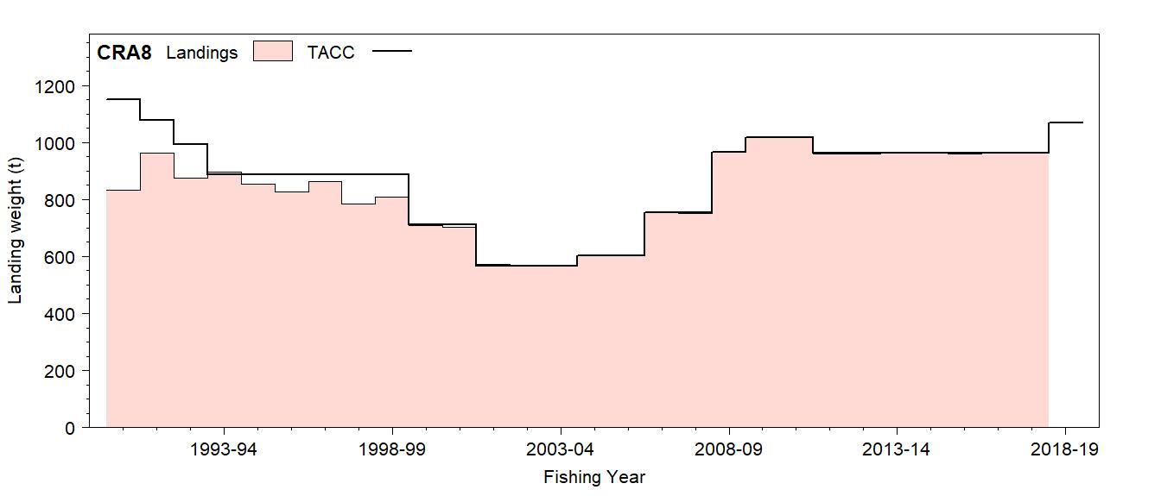
Figure 10: CRA 8 commercial landings and TACCs from 1990 to 2017.

CRA 8 Stock Status
- The results of the CRA 8 stock assessment carried out in 2015 suggested that there are no sustainability concerns for the CRA 8 fishery. Stock biomass in 2015 was 1.4 times the agreed reference level, B_{REF}. Spawning stock biomass in 2015 was 44% of the unfished level, well above the soft limit (20% of the unfished level) where it is Fisheries New Zealand policy to implement a rebuild plan.

- Standardised CPUE is considered to be a reliable indicator of relative stock size in CRA 8 and is the abundance indicator used in the CRA 8 management procedure. The CPUE type used for CRA 8 is unique in that it relates only to the fish that were landed and does not consider fish that were of legal size but were legally returned to the water. Unlike other rock lobster fisheries, a lot of fish are returned to the water in CRA 8: an estimated 40% by weight.

- The history of CRA 8 commercial CPUE is shown in Figure 11. CPUE increased steadily from 1998 to 2012, declined slightly before increasing again from 2011 to a CPUE of 4.2 kg/potlift in 2018 (the highest CPUE in the observed history).

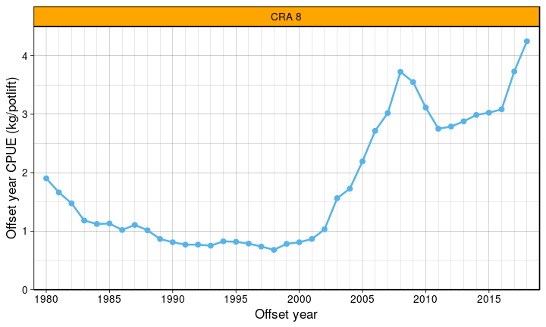
Figure 11: CRA 8 CPUE 1980 to 2018 (kg/potlift).

The Current CRA 8 management procedure
- The Government agreed to use the current CRA 8 management procedure to the 2020/21 fishing year. A graphical representation of the CRA 8 management procedure is provided in Figure 12. The CRA 8 management procedure is unique in that it uses information only from retained legal state catch. This reflects the focus to both manage at higher biomasses and maximise economic return. The graph shows the proposed TACC for the next year as a function of CPUE in the current year.

- When the rule was operated with the 2018 CPUE of 4.25 kg/potlift, it resulted in a TACC of 1,129.6 tonnes for the 2019/20 fishing year (shown by the pink symbol on the graph).
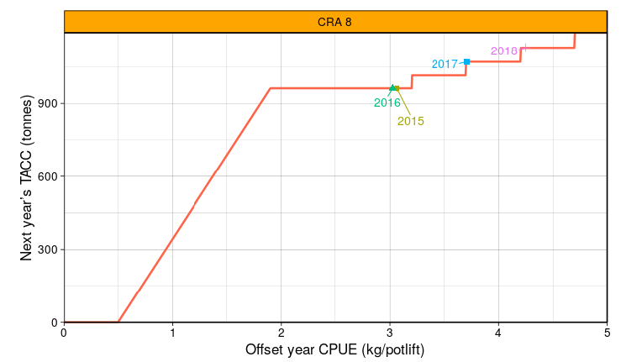
Figure 12: The current CRA 8 management procedure, showing the TACCs resulting from evaluations performed from 2015 to 2018 (shown as coloured shapes) for the 2015/16 to 2019/20 fishing years.

Proposed CRA 8 Options
- Table 7 provides a summary of the options proposed for CRA 8. The current CRA 8 management procedure has been used to guide TAC setting options. The proposals to increase the TAC and TACC will provide for increased utilisation opportunities whilst ensuring sustainability.

Table 7: Proposed management options in tonnes for CRA 8 from 1 April 2019.
Option |  |  | Allowances
 | TAC | TACC | Customary Māori | Recreational | Other mortality
CRA8_01: Status quo | 1,161.7 | 1,070.7 | 30 | 33 | 28
CRA8_02: Based on the operation of the CRA 8 management procedure | 1220.6 (5.1%) | 1,129.6 (5.5%)

Total Allowable Catch

- For CRA 8, the biomass level that can produce the maximum sustainable yield (B_{MSY}) is not known. An MSY-compatible reference level, B_{REF}, is instead used for CRA 8. Because of this, any variation of the CRA 8 TAC must be done having regard to section 13(2A). For further information on the Minister’s statutory considerations refer to Appendix 1.

- Under Option CRA8_01, the CRA 8 TAC would stay at its current level of 1,161.7 tonnes from 1 April 2019. This option could result in increased abundance in the CRA 8 fishery in the short-term, increased non-commercial catches and catch rates compared with Option CRA8_02, and higher CPUE for commercial fishers, which may result in reduced harvesting costs. But, at the cost of not being able to take advantage of the proposed TACC increase under Option CRA8_02.

- Under Option CRA8_02, the CRA 8 TAC would be increased to 1,220.6 tonnes. The proposed TAC increase is guided by the use of the CRA 8 management procedure that was agreed to in 2016 from the 2016/17 to 2020/21 fishing years. The National Rock Lobster Management Group supports the use of management procedures unless there are compelling reasons in a particular case not to follow the procedure.

- The 2015 Ongoing application of the CRA 8 management procedure is expected to maintain the stock above B_{REF} with greater than 50% probability. Simulation testing indicates it would maintain the stock above B_{REF} with 99% probability. This is likely to provide increased utilisation benefits for all sectors.

Allowances

- Table 8 provides a summary of information on current non-commercial allowances for CRA 8 and stock assessment assumptions of non-commercial catch.

Table 8: Current CRA 8 allowances and model assumptions of non-commercial catches (in tonnes).
CRA 8 | Customary  Māori | Recreational | Other mortality | Total
Current allowances | 30 | 33 | 28 | 91
Non-commercial catch assumptions  for the 2015 stock assessment | 10 | 20 | 3 from  2011 to 2014 | 33

Customary Māori fishing
- No change is proposed to the 30 tonne customary Māori allowance, because current harvest is considered to be conservative and is well within the allocation for this interest at this time.

Recreational fishing
- No change is proposed to the 33 tonne recreational allowance for CRA 8. While there is uncertainty in the current estimate of recreational catch, it is considered to be within the current 33 tonne allowance.

- The 33 tonne recreational allowance was first set in 2009 on the basis of estimates available from surveys at the time, which are now considered to be biased and likely to be overestimates. A new CRA 8 recreational harvest estimate is expected in 2019 from the 2017/18 National Panel Survey of recreational harvest. This estimate will be considered in future allowance setting, or in a review of other management controls for recreational fishers.

Other mortality
- No change is proposed to the 28 tonne CRA 8 allowance for other sources of fishing-related mortality. An estimate of handling-related mortality is not currently available for CRA 8, and will be estimated at the time of the next proposed CRA 8 stock assessment in 2020. This information will be considered in future allowance setting.

Total Allowable Commercial Catch

- Under Option CRA8_01, the CRA 8 TACC would stay at its current level of 1070.7 tonnes. This option would maintain the current level of utilisation of the commercial fishery without realising the potential for increased sustainable utilisation for commercial fishers.

- Under Option CRA8_02, the CRA 8 TACC would be increased to 1,129.6 tonnes from 1 April 2019, as guided by the use of the CRA 8 management procedure. The proposed 58.9 tonne TACC increase has the potential to result in an increase in annual revenue to the catching sector alone of $4.69 million (based on 2017 average port price information).
Discussion questions:
- Do you agree that these are the correct options to consider? If not, why not?

Other Relevant Matters

Deemed Value Rates
- Deemed values are charges commercial fishers must pay for every kilogram of stocks landed in excess of their Annual Catch Entitlement (ACE) holdings. The purpose of the deemed value framework is to encourage commercial fishers to balance their catch with ACE.

- Under section 75 of the Act, the Minister must set annual and interim deemed value rates for all stocks managed in the Quota Management System and may vary such rates, after considering specific matters. Any deemed value set takes effect from the first day of the next fishing year for the stock concerned. The annual deemed value rate must be greater than the interim deemed value rate.

- The interim deemed value rate for all rock lobster stocks (including CRA 3, 4, and 8) is currently set at 90% of the annual deemed value rate. As the current interim and annual deemed value rates are consistent with the Deemed Value Guidelines, no changes are proposed to the deemed value rates for any rock lobster stocks, as outlined in Table 9.

Table 9: Standard Deemed Value Rates ($/kg) for all rock lobster stocks.
Interim Rate ($/kg) | Annual Differential Rates ($/kg) for excess catch (% of ACE)
 | 100-120% | 120-140% | 140-160% | 160-180% | 180-200% | 200%+
99.00 | 110.00 | 132.00 | 154.00 | 176.00 | 198.00 | 220.00

Further Information

- Should you require further information, please see:

Fisheries Act (1996):

http://www.legislation.govt.nz/act/public/1996/0088/latest/DLM394192.html

Operational management procedure for New Zealand rock lobster stocks:

Fisheries research report available here: https://www.mpi.govt.nz/dmsdocument/29627/send [12MB].

November 2017 Fisheries Assessment Plenary Report:

For information on rock lobster biology, stock assessment and stock status refer to the November 2017 Fisheries Assessment Plenary report.
http://fs.fish.govt.nz/Doc/24542/14-CRA_2017_FINAL.pdf.ashx [2.6MB].

Harvest Strategy Standard:

Harvest Strategy Standard for New Zealand Fisheries. (2008). Compiled by the Ministry of Fisheries, Wellington, New Zealand, 27 p.
(http://fs.fish.govt.nz/Page.aspx?pk=104)

Previous reviews of the stocks:

CRA 2, 4, 7 and 8 Sustainability Round Review April 2018:
https://www.mpi.govt.nz/dmsdocument/27966-review-of-rock-lobster-sustainability-measures-1-april-2018

CRA 3, 4 and 7 Sustainability Round Review April 2017: https://www.mpi.govt.nz/dmsdocument/16879-review-of-rock-lobster-sustainability-measures-for-1-april-2017-final-advice-paper

CRA 4 and 8 Sustainability Round Review April 2016: https://www.mpi.govt.nz/dmsdocument/11611-review-of-rock-lobster-sustainability-measures-for-1-april-2016

CRA 7 Sustainability Round Review April 2015:
https://www.mpi.govt.nz/document-vault/6415

CRA 2, 4 and 7 Sustainability Round Review April 2014: https://www.mpi.govt.nz/dmsdocument/3993-review-of-rock-lobster-sustainability-measures-final-advice-paper

Appendix 1: Statutory Considerations

- This section provides an overview of the Minister of Fisheries (the Minister’s) legal obligations under the Fisheries Act 1996 (the Act) when setting or varying Total Allowable Catches (TACs) and Total Allowable Commercial Catches (TACCs) for New Zealand fishstocks.

- Where relevant, stock-specific details relating to these obligations are set out in the section of the discussion paper relating to each stock.

Section 5(a) – International Obligations
- Section 5(a) says the Act is to be interpreted, and all persons exercising or performing functions, duties, or powers under it are required to act, in a manner consistent with New Zealand’s international obligations relating to fishing. As a general principle, where there is a choice in the interpretation of the Act or the exercise of discretion, the decision maker must choose the option that is consistent with New Zealand’s international obligations relating to fishing.

- The two key pieces of international law relating to fishing, and to which New Zealand is a party, are the United Nations Convention on the Law of the Sea, 1982 and the United Nations Convention on Biological Diversity 1992. International obligations also derive from New Zealand being a signatory to a number of international conventions. Of particular relevance are regional fisheries management organisations, Convention on International Trade in Endangered Species of Wild Fauna and Flora and the Convention on Migratory Species.

Section 5(b) – Treaty of Waitangi (Fisheries Claims) Settlement Act 1992
- Section 5(b) says the Act is to be interpreted, and all persons exercising or performing functions, duties, or powers under it are required to act, in a manner consistent with the provisions of the Treaty of Waitangi (Fisheries Claims) Settlement Act 1992 (the Settlement Act). This obligation furthers the agreements expressed in the Deed of Settlement referred to in the Preamble to the Settlement Act.

- The development of customary regulations, Iwi Fisheries Forums, and providing for the input and participation of iwi in fisheries decisions, discussed elsewhere in this paper, are some of the ways in which the obligations in the Settlement Act are given effect to.

Section 8 – Purpose of the Fisheries Act 1996
- Section 8 says the purpose of the Act is to provide for the utilisation of fisheries resources while ensuring sustainability. Each utilisation and ensuring sustainability are defined in the Act:

Ensuring sustainability means—
- maintaining the potential of fisheries resources to meet the reasonably foreseeable needs of future generations; and
- avoiding, remedying, or mitigating any adverse effects of fishing on the aquatic environment.

Utilisation means conserving, using, enhancing, and developing fisheries resources to enable people to provide for their social, economic, and cultural well-being.

- The Supreme Court has stated that the purpose statement incorporates “the two competing social policies reflected in the Act” and that “both policies are to be accommodated as far as is practicable in the administration of fisheries under the quota management system....[I]n the attribution of due weight to each policy that given to utilisation must not be such as to jeopardise sustainability”.

Section 9 – Environmental principles
- Section 9 prescribes three environmental principles that the Minister must take into account when exercising powers in relation to the utilising of fisheries resources or ensuring sustainability.

Principle 1: Associated or dependent species should be maintained above a level that ensures their long-term viability.
- The Act defines “associated and dependent species” as any non-harvested species taken or otherwise affected by the taking of a harvested species. “Harvested species” is defined to mean any fish, aquatic life or seaweed that may for the time being be taken with lawful authority. So this principle is focussed on species (such as protected species) for which a permission to target commercially cannot be given.

- The term “long-term viability” (in relation to a biomass level of a stock or species) is defined in the Act as a low risk of collapse of the stock or species, and the stock or species has the potential to recover to a higher biomass level. This principle therefore requires the continuing existence of species by maintaining populations in a condition that ensures a particular level of reproductive success.

- Where fishing is affecting the viability of associated and dependent species, appropriate measures such as method restrictions, area closures, and potentially adjustments to the TAC of the target stock should be considered. There are no known associated or dependent species that will be affected by the proposals

Principle 2: Biological diversity of the aquatic environment should be maintained.
- “Biological diversity” is defined in the Act as ‘the variability among living organisms, including diversity within species, between species, and of ecosystems’. Determining the level of fishing or the impacts of fishing that can occur requires an assessment of the risk that fishing might cause catastrophic decline in species abundance or cause biodiversity to be reduced to an unacceptable level.

Principle 3: Habitat of particular significance for fisheries management should be protected.
- Habitat is defined in the Oxford Dictionary of English to mean the natural home or environment of an animal, plant or species. Fisheries New Zealand considers habitat to mean those waters and substrates necessary for fish to spawn, breed, feed or grow to maturity. These should be protected and adverse effects on them avoided, remedied, or mitigated.

- The proposals are not expected to change the environmental impacts and interactions significantly for the CRA 3, 4, and 8 fisheries. Rock lobsters are caught by potting and diving, which are selective fishing methods with low expected impacts on the benthic environment and low bycatch levels. Where TAC increases are proposed for CRA 4 and CRA 8, the proposals will provide for additional catch resulting from greater relative abundance in these fisheries, but there is unlikely to be any additional vessels. Where a TAC decrease is proposed for CRA 3, targeted fishing effort is expected to reduce.

Section 10 – Information Principles
- Section 10 prescribes four information principles that the Minister must take into account when exercising powers in relation to the utilising of fisheries resources or ensuring sustainability:
- Decisions should be based on the best available information;
- Decision makers should take into account any uncertainty in the available information;
- Decision makers should be cautious when information is uncertain, unreliable, or inadequate; and
- The absence of, or any uncertainty in, any information should not be used as a reason for postponing or failing to take any measure to achieve the purpose of the Act.

- Less than full information suggests caution in decision-making, not deferral of a decision completely. “The fact that a dispute exists as to the basic material upon which the decision must rest, does not mean that necessarily the most conservative approach must be adopted. The obligation is to consider the material and decide upon the weight which can be given it with such care as the situation requires.”

- Both scientific and anecdotal information need to be considered and weighed accordingly when making management decisions. The weighting assigned to particular information is subject to the certainty, reliability, and adequacy of that information.

- Fisheries New Zealand and the National Rock Lobster Management Group have based the analysis in this paper on the best available information and noted uncertainties where relevant.

- As a general principle, information outlined in Fisheries New Zealand’s Fishery Assessment Plenary Report is considered the best available information on stock status and should be given significant weighting. The information presented in the Plenary Report is subject to a robust process of scientific peer review and is assessed against the Research and Science Information Standard for New Zealand Fisheries. Corroborated anecdotal information also has a useful role to play in the stock assessment process and in the management process.

- The best available information has been used as the basis for the proposals in this paper. All science information on which the management proposals are based, has been peer-reviewed by one of Fisheries New Zealand’s Science working Groups and meets the Research and Science Information Standard for New Zealand’s Fisheries.

Section 11 – Sustainability Measures
- Section 11(1) allows sustainability measures (such as a TAC) to be set or varied after the following factors are taken into account:
- Any effects of fishing on the stock and the aquatic environment;
- Any existing controls that apply to the stock or area concerned; and
- The natural variability of the stock concerned.

- Section 11 (2) says that before any sustainability measure is set or varied the Minister must have regard to any provision of–
- Any regional policy statement, regional plan, or proposed regional plan under the Resource Management Act 1991;
- Any management strategy or management plan under the Conservation Act 1987 that apply to the coastal marine area and which the Minister considers to be relevant;
- Sections 7 and 8 of the Hauraki Gulf Marine Park Act 2000;
ca) Regulations made under the Exclusive Economic Zone and Continental Shelf (Environmental Effects) Act 2012; and
- A planning document lodged with the Minister of Fisheries by a customary marine title group under section 91 of the Marine and Coastal Area (Takutai Moana) Act 2011–
that apply to the coastal marine area and are considered to be relevant.

- Section 11 (2A) requires the Minister to take into account:
- Any conservation services or fisheries services;
- Any relevant fisheries plan approved under this Part (see discussion of section 11A below); and
- Any decisions not to require conservation services or fisheries services.

- Services of particular relevance to this paper relate to programmed research used to monitor stock abundance. To date, national fisheries plans have been approved only for deepwater and highly migratory species.

- With respect to natural variability of rock lobster stocks, a variety of environmental factors are thought to influence the productivity of rock lobster populations including water temperature, ocean currents, latitude, shelter availability, and food availability. Studies have shown that lobsters grow at different rates around New Zealand and female lobsters become mature at different sizes. The development of management procedures for the rock lobster stocks discussed in this paper take into account variability in growth, maturity, available abundance, and recruitment.

Section 12 – Consultation and Input and Participation of Tangata Whenua
- Section 12(1) says that before setting or varying any sustainability measure under the Act the Minister is required to:
- Consult with those classes of persons having an interest in the stock or the effects of fishing on the aquatic environment in the area concerned, including, but not limited to, Māori, environmental, commercial and recreational interests; and
- Provide for the input and participation of tangata whenua having a non-commercial interest in the stock concerned or an interest in the effects of fishing on the aquatic environment in the area concerned; and have particular regard to kaitiakitanga.

- The Act defines kaitiakitanga to mean “the exercise of guardianship; and, in relation to any fisheries resources, includes the ethic of stewardship based on the nature of the resources, as exercised by the appropriate tangata whenua in accordance with tikanga Māori”, where tikanga Māori refers to Māori customary values and practices.

- Iwi Fisheries Forums and Forum Fisheries Plans provide a view of the objectives and outcomes iwi seek from the management of the fishery and can provide an indication of how iwi exercise kaitiakitanga over fisheries resources. Iwi views from Forum meetings and submissions received from iwi can also provide an indication.

Input and participation to National Rock Lobster Management Group meetings
- A Te Waka a Māui me Ōna Toka Iwi Forum representative (from the iwi forum that covers the South Island) is a member of the National Rock Lobster Management Group who directly inputs into decision-making on behalf of South Island tangata whenua. A representative of Te Ohu Kaimoana is also is a member of the National Rock Lobster Management Group, who support relevant iwi to provide feedback on rock lobster proposals each year.

The CRA 3 and CRA 4 proposals
- The proposals to consult on CRA 3 and CRA 4 were presented at a multi-sector meeting on 29 November 2018 in Napier where research ideas were being discussed for various species. This meeting included tangata whenua representatives from Mahia to Wairarapa. No concerns were expressed about the proposals.

- The proposal to consult on CRA 4 was also presented to Te Taihauauru Iwi Fisheries Forum on 16 November 2018. Te Taihauauru represents iwi and hapu along the western side of the lower North Island, from the Mokau River in north Taranaki through to Waikanae in the south. The forum did not have any specific feedback on the CRA 4 proposal. Only a small proportion of the CRA 4 fishery falls within the Forum’s rohe.

- The majority of the CRA 3 and CRA 4 management areas do not have a Iwi Forum Fisheries Plan. The Te Taihauāuru Iwi Forum Fisheries Plan encompasses a small part of the CRA 4 area from north of Waikanae to the Manawatu River.

- The Te Taihauāuru Iwi Forum Fisheries Plan notes that rock lobster is an important species (described as taonga by some iwi), both significant in terms of its integral role in cultural practices, and economically significant as a result of the income it generates. The Plan contains three objectives which are relevant to the management options proposed for CRA 4:
  - Management objective 1: customary non-commercial fiesheries are healthy, sustainable, and support the cultural wellbeing of Te Taihauāuru Iwi;
  - Management objective 2: commercial fisheries are sustainable and support the economic wellbeing of Te Taihauāuru Iwi; and
  - Management objective 3: mana and rangatiratanga over our fisheries is restored, preserved and protected for future generations.

- The National Rock Lobster Management Group and Fisheries New Zealand consider that the management options presented in this advice paper will contribute towards the achievement of these three management objectives in ensuring that appropriate allowances are made for customary non-commercial fishing, the fishery remains sustainable, and that environmental impacts are minimised.

CRA 8 proposals
- The proposal to consult on CRA 8 was presented to Te Waka a Māui me Ōna Toka Iwi Forum in November 2017 and they were supportive of the proposals for these fisheries. The Te Waka a Māui me Ōna Toka Iwi Forum represents all nine iwi of the South Island, each holding mana moana and significant interests (both commercial and non-commercial) in South Island fisheries. Of these iwi, Ngai Tahu is most relevant, as CRA 8 falls within their rohe.

- Rock lobster (koura) is identified as a taonga species in the South Island Te Waipounamu Iwi Fisheries Plan. The Plan contains three objectives which are relevant to the management options proposed for CRA 8:
- Management objective 1: to create thriving customary non-commercial fisheries that support the cultural wellbeing of South Island iwi and our whānau;
- Management objective 3: to develop environmentally responsible, productive, sustainable and culturally appropriate commercial fisheries that create long-term commercial benefits and economic development opportunities for South Island iwi; and
- Management objective 5: to restore, maintain and enhance the mauri and wairua of fisheries throughout the South Island.

- The National Rock Lobster Management Group and Fisheries New Zealand consider that the management options presented in this advice paper will contribute towards the achievement of these three management objectives in ensuring that appropriate allowances are made for customary non-commercial fishing, the fishery remains sustainable, and that environmental impacts are minimised.

- Section 12 (2) says that as soon as practicable after setting or varying any sustainability measure, the Minister shall give the persons consulted under 12(1), the reasons in writing for his or her decisions.

Section 13 - Setting and Variation of The Total Allowable Catch
- A central consideration when choosing whether to use a management procedure to guide TAC setting in a rock lobster fishery is whether the procedure enables the Minister to set a TAC that complies with section 13 of the Act.

- Under section 13 the general premise is to set a TAC that maintains the biomass of a stock at or above a level that can produce the maximum sustainable yield (MSY). That biomass level is abbreviated as B_{MSY}.

- Under section 13(2) of the Act, the Minister must set a TAC that maintains a stock at or above a level that can produce the MSY, in a way that will result in the stock being restored to or above a level that can produce the MSY, having regard to the interdependence of stocks. However, before a TAC can be set under section 13(2) the Minister must be provided with an assessment of both current biomass and the biomass that can produce MSY.

- Where current biomass or B_{MSY} estimates are not available or not reliable, then the Minister is required to apply section 13 (2A) of the Act for the purposes of setting a TAC. Section 13 (2A) requires the Minister to set a TAC using the best available information, and ensuring that the TAC is not inconsistent with the objective of maintaining the stock at or above, or moving the stock towards or above, a level which can produce the MSY.

- The Minister may set the TAC to achieve the objective in a way and rate which has regard to the interdependence of stocks and within a period appropriate to the stock. In considering the way and rate in which a stock is moved towards or above a level that can produce the MSY under section 13(2)(b) or (c) or (2A), the Minister must have regard to such social, cultural and economic factors that are considered relevant.

- The management procedures discussed in this paper are designed to move stock biomass to, or maintain the biomass of each stock at, a size at or above agreed reference levels (i.e. B_{REF}) as required under section 13 of the Act.

- When setting a TAC under section 13, the Minster must also have regard to the biological characteristics of the stock, and any environmental conditions affecting the stock.

Interdependence of stocks
- The obligation to have regard to the interdependence of stocks when setting a TAC under section 13 requires consideration of the effects of fishing on associated stocks harvested with the target stock. Examples include other non-target species (bycatch) or benthic species that are incidentally impacted by fishing gear. The role of the target stock in the food chain should also be considered. In particular, independence involves a direct trophic (i.e. one stock is likely to be directly affected through a predator-prey relationship by the abundance of another stock) relationship between stocks.

- Potting is the main method commercial fishers use to target rock lobster. This method is considered to have very little direct effect on non-target species and benthic species. The most frequently reported incidental species caught via commercial rock lobster potting, in decreasing order of catch across all stocks are: octopus, conger eel, blue cod, trumpeter, sea perch, red cod, butterfish and leatherjackets. This is based on an analysis of estimated incidental catches for the period 1989 to 2003. The non-rock lobster catch ranged from 2 to 11% of the estimated rock lobster catch weight per stock over this period.

- Rock lobsters are predators of molluscs and other invertebrates, and predation on rock lobsters is known from octopus, blue cod, groper, southern dogfish, rig and seals. Predation by rock lobsters has been suggested as contributing to trophic cascades in a number of studies in New Zealand, particularly in the Greater Hauraki Gulf (i.e. if fished predators such as rock lobster, snapper and blue cod are reduced to certain levels urchin-grazed kelp ‘barrens’ can form). However, other research suggests that the loss of kelp beds is driven by other factors such as change in water temperature, increasing sedimentation, storms and poor nutrients. A literature review (Breen unpublished) suggests that the evidence for lobster-driven trophic cascades at a national scale is limited.

Biological characteristics and environmental conditions
- When setting a TAC under section 13, the Minister must also have regard to the biological characteristics of the stock and any environmental conditions affecting the stock. A variety of environmental factors are thought to influence the productivity of rock lobster populations, including water temperature, ocean currents, latitude, shelter availability, and food availability. Studies have shown that lobsters grow at different rates around New Zealand and female lobsters become mature at different sizes.

- Variability in growth, maturity, available abundance, and recruitment were taken into account during the development of management procedures for the rock lobster stocks discussed in this paper.

Sections 20 & 21 - Setting and Variation of the Total Allowable Commercial Catch
- After setting or varying the TAC, a separate decision arises in respect of allocating the TAC.

- When setting a TACC for a stock under section 20 of the Act, section 21 requires the Minister to have regard to the TAC for that stock and allow for Māori customary non-commercial fishing interests, recreational interests, and all other sources of fishing-related mortality to that stock (including illegal catch and handling-related mortality).

- The Act does not provide an explicit statutory mechanism to apportion available catch between sector groups either in terms of a quantitative measure or prioritisation of allocation. Accordingly, the Minister has the discretion to make allowances for various sectors based on best available information.

- The Courts have in a number of cases considered what is involved in allowing for non-commercial interests. In Snapper 1, the Court of Appeal said that the recreational allowance is simply the best estimate of what recreational fishers will catch while being subject to the controls which the Minister decides to impose upon them, e.g. bag limits and minimum lawful sizes. Having set the TAC, the Minister in effect apportions it between the relevant interests.

- The Supreme Court in Kahawai endorsed this approach and said that the words “allow for” require the Minister both to take into account the interests and make provision for them in the calculation of the TACC. The Supreme Court went on to say that sections 20 and 21 prescribe a framework within which the Minister must operate when setting the TACC. The framework requires apportionment of the TAC by the Minister among the various interests and other mortality. The sequential nature of the method of allocation provided for in section 21 does not indicate that non-commercial fishing interests are to be given any substantive priority over commercial interests. In particular, the allowance for recreational interests is to be made keeping commercial interests in mind.

- The Supreme Court further said that in the end, within the limits provided for by the Act, the Minister makes a policy decision as to what allocations are appropriate for non-commercial interests and other mortality, and what is to be the TACC. These decisions are interdependent. The Act does not confer priority for any interests over the other. It leaves that to the Minister’s judgment.

- The Courts have also commented on the Minister’s responsibilities in respect of allowances. The allowance represents what the Minister considers recreational interests should be able to catch, but also all that they will be able to catch. The Act envisages that the relevant powers will be exercised as necessary to achieve that goal. Both the law and common sense dictate that a Minister should not reduce the TACC for conservation reasons unless able to take, and taking, reasonable steps to avoid the reduction being rendered futile through increased recreational fishing.

- When allowing for Māori customary non-commercial fishing interests, the Minister must take into account any relevant mātaitai reserves within the relevant quota management areas and any area closure or fishing method restriction or prohibition within those areas made under section 186A of the Act. There are a number of mātaitai reserves and temporary closures that fall within the areas of the rock lobster stocks discussed in this document. The intent is that the purpose of measures enacted to provide for customary fishing are not adversely affected, or reasons for limited customary take are ignored, when setting the customary allowance.

- When allowing for recreational interests, the Minister must take into account any regulations made under section 311 of the Act that close an area or areas to commercial fishing for a stock. There are currently no section 311 regulations applying in the areas of the rock lobster stocks discussed in this paper.

Standardised commercial CPUE from October to September (“offset year CPUE”) is used as an input to all the management procedures discussed in this document. Use of offset year CPUE ensures the most up-to-date CPUE information is used in management procedure evaluations and decision-making.
The CRA 7 management procedure was evaluated with a new model in 2015, extending its use until the 2020/21 fishing year.
For further technical information on management procedures for New Zealand rock lobster refer to the fisheries research report available for download from the Fisheries New Zealand website here: https://www.mpi.govt.nz/dmsdocument/29627/send [12MB].
Stock size is measured in terms of autumn-winter vulnerable biomass for the B_{REF} indicator. “Vulnerable biomass” is the biomass that is available to be caught legally: above the minimum legal size and not egg bearing if female.
The Operational Guidelines for the Harvest Strategy Standard describe the B_{REF} concept as follows: “Conceptual proxies for B_{MSY}, F_{MSY} and MSY are qualitative surrogates that can be used in the absence of adequate information to directly estimate these reference points themselves. The conceptual interpretation embraces the spirit and intent of section 13 of the Act. It can be used in cases where there is insufficient information to estimate B_{MSY}, F_{MSY} or MSY explicitly, or where such estimates may be unreliable because, for example, there is little or nothing known about the stock recruitment relationship. In cases where the relationship between CPUE and abundance can be assumed to be more or less proportional, or where some other form of relationship has been derived from data, it may be reasonable to select an appropriate historical period when both CPUE and catches were relatively high and to use this CPUE level as a target. The best example in current use in New Zealand is that for rock lobster.” [emphasis added].
With a coefficient of variation of 33% (the ratio of the standard deviation to the mean).
Section 111 catches (taken under section 111 of the Fisheries Act 1996) are taken by commercial fishers for non-commercial purposes (i.e. a maximum of 2.94 tonnes of rock lobster in CRA 3).
In 2003 and 2004, the TACC was substantially under caught because of voluntary Annual Catch Entitlement shelving by the CRA 3 industry, which was informed by a management procedure.
B_{REF} is not reported for CRA 3 because it is not considered a useful indicator at this time.
The 2017/18 port price for rock lobster was $79.58 per kg.
With a coefficient of variation of 17% (the ratio of the standard deviation to the mean).
Section 111 catches are taken by commercial fishers for non-commercial purposes (i.e. a maximum of 5.8 tonnes of rock lobster in CRA 4)
B_{REF} for CRA 4 is the average pre-season autumn-winter vulnerable biomass associated with the period 1979-88.
The 2017/18 port price for rock lobster was $79.58 per kg.
With a coefficient of variation of 60% (a measure of the ratio of the standard deviation to the mean).
B_{REF} for CRA 8 is the average pre-season autumn-winter vulnerable biomass associated with the period 1979-81.
The 2017/18 port price for rock lobster was $79.58 per kg.
Available at www.mpi.govt.nz/document-vault/3663
Recreational Fishing Council Inc v Sanford Limited and Ors [2009] NZSC 54 at [39].
Greenpeace NZ Inc v Minister of Fisheries (HC, Wellington CP 492/93, 27/11/95, Gallen J) p 32.
A nonbinding Ministry for Primary Industries Policy Document.
New Zealand Fishing Industry Association (Inc) v Minister of Fisheries CA 82/97, 22 July 1997 (“Snapper 1”).
Snapper 1, p 17.
New Zealand Recreational Fishing Council Inc v Sanford Limited [2009] NZSC 54 (“Kahawai”)
Kahawai [55]
Kahawai [61]
Kahawai [65]
Kahawai [56]
Snapper at 101-102

